Doctor's name | Expertise
Dr. Taniya Amini  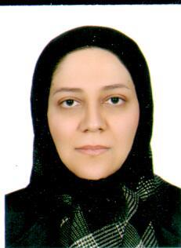 | Obstetricians
Dr. Farahnaz Keshavarz | sterility Fellowship
Dr. Nasrin Jalilian  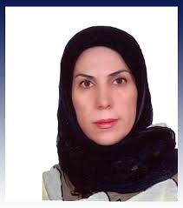 | sterility Fellowship
Dr. Batoole Abrashpoor  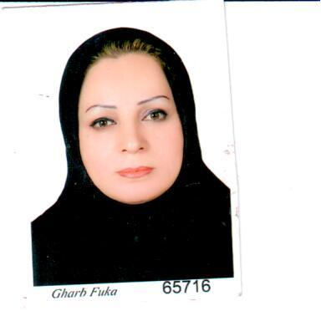 | Obstetricians
Dr. Elham Kheirollahi  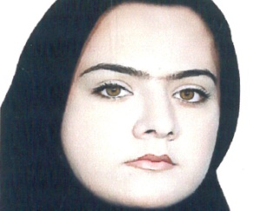 | Obstetricians
Dr. Mojgan Chaghakaboodi  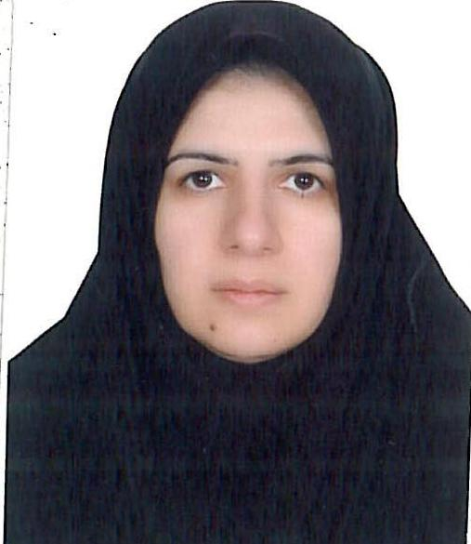 | Obstetricians
Dr. Mojgan Rajaati  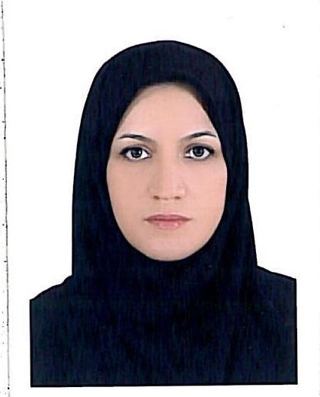 | Obstetricians
Dr. Jahangir Sayadi  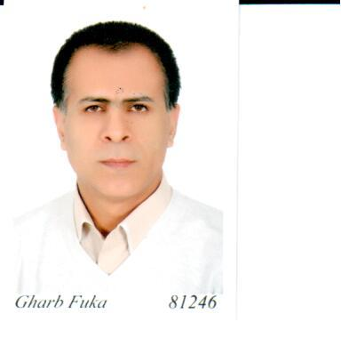 | Neonatal specialist
Dr. Yegane Pasharavesh  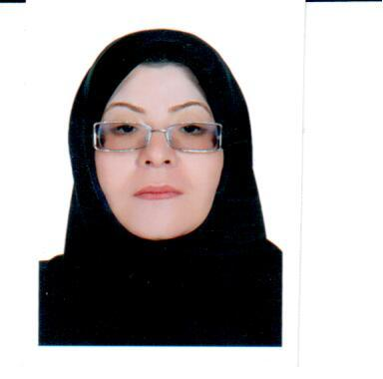 | Neonatal specialist

