Hysterectomy suggests an operation that removes the uterus. This is the most common practice performed by the gynecologist and in full (trunk, fundus and cervix) or partial (cervical cancer).
After removing the uterus, the woman loses the ability to have a baby (also removes the fallopian and ovarian tubes). If this is done before menopause, menopause may occur earlier, and if the fallopian tube or ovary is also taken with the uterus, the person enters menopause. Hysterectomy, as well as other surgical procedures, results in dangers during surgery and post-operative effects. That's why surgery is recommended when there is no other way to treat it.
Aphorectomy (removal of ovaries) is usually accompanied by hysterectomy to reduce the risk of ovarian cancer.
This is usually done by cutting the lower part of the abdomen (Sperpobic) by 10 cm
The duration of hospitalization in this center is approximately 3 to 4 days
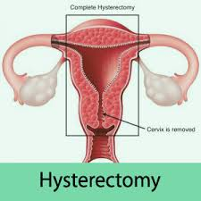

The dollar is calculated at the rate of 18/10/2018: 120000 Rials
Description: The cost of services provided on the dollar at the current rate is calculated.
Price:303.60 dollar

